**Insurance Information System**

**Karumazondo Tinashe Lewis**

**R1711779**

**Software Requirements Specification**

**Document**



Table of Contents

**Initial Requirements Engineering** 3

**1.** **Introduction** 3

**1.2** **Purpose** 3

**1.3** **Scope** 4

**1.4** **Definition, Acronyms and Abbreviations** 4

**1.5** **Overview** 5

**2** **Current System** 5

**3** **Proposed System** 6

**3.1** **Overview** 6

**3.2** **Functional Requirements** 6

**3.3** **Non-Functional Requirements** 8

**3.3.1** **Performance Requirements** 8

**3.3.2** **Design Constraints** 8

**3.3.3** **Standards Compliance** 8

**3.3.4** **Reliability** 8

**3.3.5** **Availability** 8

**3.3.6** **Security** 8

**3.3.7** **Maintainability** 9

**3.3.8** **Portability** 9

**System Model** 10

**4.1** **UML Diagrams** 10

**4.1.1** **Class Diagrams** 10

**4.1.2** **Activity Diagrams** 12

**4.1.3** **Use Case Diagrams** 13

**Initial Requirements Engineering**

1. **Introduction**

The following subsections of the Software Requirements Specifications (SRS) document provide an overview of the entire SRS.

* 1. **Purpose**

Software Requirements System provides a foundation of the project. The Software Requirement Specification will make an attainable description of the requirements of the Insurance Information System. The SRS will acknowledge a complete understanding of what the developed system is must do. A transparent understanding of the Insurance Information System(IIS) and the functions will allow a platform for correct software development for the users and this will also be used for developmental purposes of the future stages of the project. Clearly, by this Software Requirements System, the Insurance Information System can be designed, model and tested. The system analyst and developer(me) will use the SRS to understand the expectations the proposed system to develop the suitable or proper system for the users. The end users can use this Software Requirement System as a test to monitor if the system developer is developing the system to their requirements. If the end users to do not agree with any functionality, they will notify the developer and exceptions are made so that the system suitably fits the end user requirements.

* 1. **Scope**

Insurance Information System with the major aim of computerizing or automating the operations of the Glow Insurance company. The most important of all is the premium calculator is to monitor number of accidents, amount insured on the vehicle, the claimant and different base insuring amounts. This system will also keep track of all staff within the company which is the agents, receptionist, company officials and administrators. The administrator is responsible for monitoring user accounts. The company officials oversee and in times grant policies to those clients with exceptions, complications or rather who do not meet requirements.

This system will have the following:

1. Admin

* The admin manages the user accounts
* Admin adds, edit and delete users’ information
* Create new users

1. Receptionist

* Adds clients’ details
* Views clients’ database
* Grants policies
* Views policies database
* Manipulates user information
* Adds Agents
* Views Agents database
* Uses premium calculator

1. Agents

* Adds clients
* Views polices databases
* Uses premium calculator

1. Company Officials

* Views clients’ database
* Generates new policies
* Deletes policies
* Views staff database
* Views policies database
* Grants policies

The proposed system which the developer is going develop will solve problems currently being faced by the users and clients. Integrating to the system, will be an advantage to both clients and users. Advantages include less paperwork, saves time, its efficient in daily activities and secure.

* 1. **Definition, Acronyms and Abbreviations**

SRS – Software Requirement Specifications

End users – the users of the system

IIS – Insurance Information System

* 1. **Overview**

The SRS has 2 main subsections. These are:

1. The Overall Description
2. Specific Requirements

The Overall Description will describe the requirements of IIS from a general level perspective. The Specific Requirements Section Will describe in detail the requirements of the system.

1. **Current System**

Glow Insurance Company is currently facing major problems of loss of customers due to the slowness of the current system. There is a lot space available in the offices but there are too many papers scattered around. The company uses old process of record keeping system that is by using files and papers. This information can be misused or may include wrong entries which will not able to provide correct information. If any error occurs, then manual search and updating process is required to correct that particular information. They use index cards therefore there are security concerns. Most of the problems have led the company to be financially unstable. There are also damages caused due to loss in reputation of the firm. The project’s aim is to build a fully functional system that is efficient and less time consuming.

Current system deficiencies:

1. There is duplication of records - The same data gets repeated over and over since the workers find it hard to keep track of the documents, information and transactions.
2. No data validation and verification – The current system does not check if the data entered is valid.
3. No backup.
4. Data lost or damaged will never be recovered since there is no proper back-up e.g. If the papers catch a fire then they are completely destroyed.
5. Poor security - since data is stored in filing cabinets it is freely available to anyone, hence can be tampered with.
6. Tire some to use since most operations are done by manually by men.
7. Very slow processing, because of low speed and poor facilities, more time is spent writing on paper each and every detail that needs to be captured.
8. The system is prone to too many errors since it is done manually.
9. More employees will be required because the system is manual.
10. Higher costs of operation like stationery expenses, security etc.
11. Needs extra care and additional storage place - since the data and paper is stored in filing cabinets it consumes too much space, as the amount of work done on paper increases, it continuously requires expansion the storage cabinets as well.
12. **Proposed System**

The proposed system will able to improve the main business operations. The developer’s solution of old paper based record keeping is to develop a software that will solve the problem and computerize file handling. The proposed system will solve some of the following:

* It will have a user friendly interface specifically developed for the organisation.
* It will reduce the cost of stationery.
* There is no duplication of work.
* There is granting of access privileges hence better security of information stored.
* Will reduce workload on workers hence saves time and money.
* Supports system security and confidentiality of information.
  1. **Overview**

The overview consists of the current background in a summary of the company and how the developer is going to solve and overcome the problems the proposal. In this modern world, technology is growing so fast and quickly therefore having an automated or computerized system improves the business operations and reputation.

* 1. **Functional Requirements**

Functional requirements are a part of [requirements analysis](https://searchsoftwarequality.techtarget.com/definition/requirements-analysis) (also known as requirements engineering), which is an interdisciplinary field of engineering that concerns the design and maintenance of complex systems. Functional requirements describe the desired end function of a system operating within normal parameters, so as to assure the design is adequate to make the desired product and the end product reaches its potential of the design in order to meet user expectations. the functional requirements for the proposed system are divided into a few categories which are Management, Work flow and administration. For more detailed functional requirements, refer to use case diagrams.

1. Administrator

* The system will create new users
* The system will delete users
* The system will edit user accounts information

1. Staff

* The system will display the staff members’ details:

1. Employee Number
2. Name
3. Address
4. Age
5. Gender
6. Category
7. Salary
8. Client

* The system will display the clients’ details:

1. Policy Number
2. Type of policy
3. Registration Number
4. Vehicle Type
5. Vehicle Make
6. Name
7. Age
8. Gender
9. Contact details
10. Address
11. Insured amount
12. Number of accidents
13. Premium calculator

* The system will be able to calculate premium as per policy

1. Company officials

* The system will view staff details
* The system will revise policies
* The system will generate new policies
* The system will monitor company progress
* The system will grant/deny policies

1. Agents

* The system will add clients’ name, gender and address
* The system will capture clients’ policy number
* The system will capture clients’ vehicle details (Reg number and Make)
* The system will capture clients’ contact details and address
* The system will capture clients’ insured amount and possible claimant
* The system will use premium calculator
* The system will grant/deny policies
* The system will record payments
* The system will record type of payment

1. Receptionist

* The system will add clients’ name, gender and address
* The system will capture clients’ policy number
* The system will capture clients’ vehicle details (Reg number and Make)
* The system will capture clients’ contact details and address
* The system will capture clients’ insured amount and possible claimant
* The system will grant/deny policies
* The system will record payments
* The system will record type of payment
* The system will view clients’ database
* The system will view agents’ database
* The system will manipulate user information
* The system will use premium calculator
  1. **Non-Functional Requirements**

 Non-functional requirement (NFR) is a [requirement](https://en.wikipedia.org/wiki/Requirement) that specifies criteria that can be used to judge the operation of a system, rather than specific behaviours. They are contrasted with [functional requirements](https://en.wikipedia.org/wiki/Functional_requirement) that define specific behaviour or functions. The plan for implementing functional requirements is detailed in the [system design](https://en.wikipedia.org/wiki/Systems_design). The plan for implementing non-functional requirements is detailed in the [system architecture](https://en.wikipedia.org/wiki/Systems_architecture), because they are usually [architecturally significant requirements](https://en.wikipedia.org/wiki/Architecturally_significant_requirements).

* + 1. **Performance Requirements**

Performance requirements define acceptable response times for system functionality.

* Queries will show results within a period of 5-8 seconds
* The login information will be verified within 5-8 seconds
* The load time for use interface shall be less than 5 seconds
  + 1. **Design Constraints**

The Insurance Information System will be a stand-alone system that will be running on windows operating system. The system will be developed using the language C++.

* + 1. **Standards Compliance**

There shall be correspondence in variable naming within the system. The user interface shall be friendly.

* + 1. **Reliability**

This specifies the resources required to set up the required reliability of the software system at time of delivery.

* + 1. **Availability**

The IIS will be available during normal working hours.

* + 1. **Security**

Company officials will be able to login and use all other functions except for admin. The Agents and Receptionist will be able to login and deal with clients related functions only. Access to various subsystems will be protected due to different user rights. The login screen requires username and password.

* + 1. **Maintainability**

The Insurance Information System is being developed in C++. C++ is an object-oriented programming language and it will be easy to maintain.

* + 1. **Portability**

The IIS will run on Microsoft Windows operating system (XP, Vista, Windows 7, Windows 8, Windows 8.1 or Windows 10)

**System Model**

* 1. **UML Diagrams**
     1. **Class Diagrams**

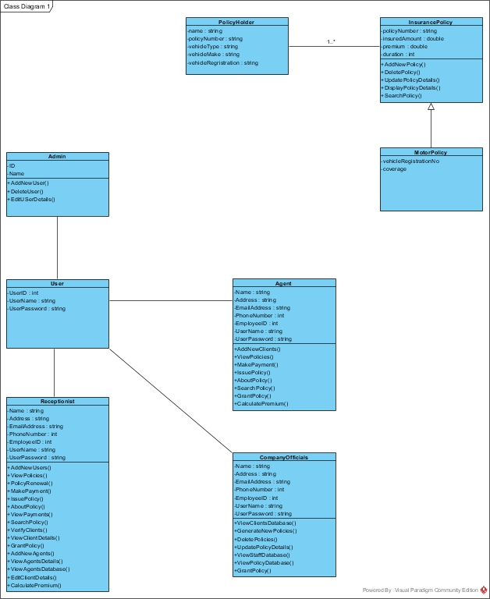

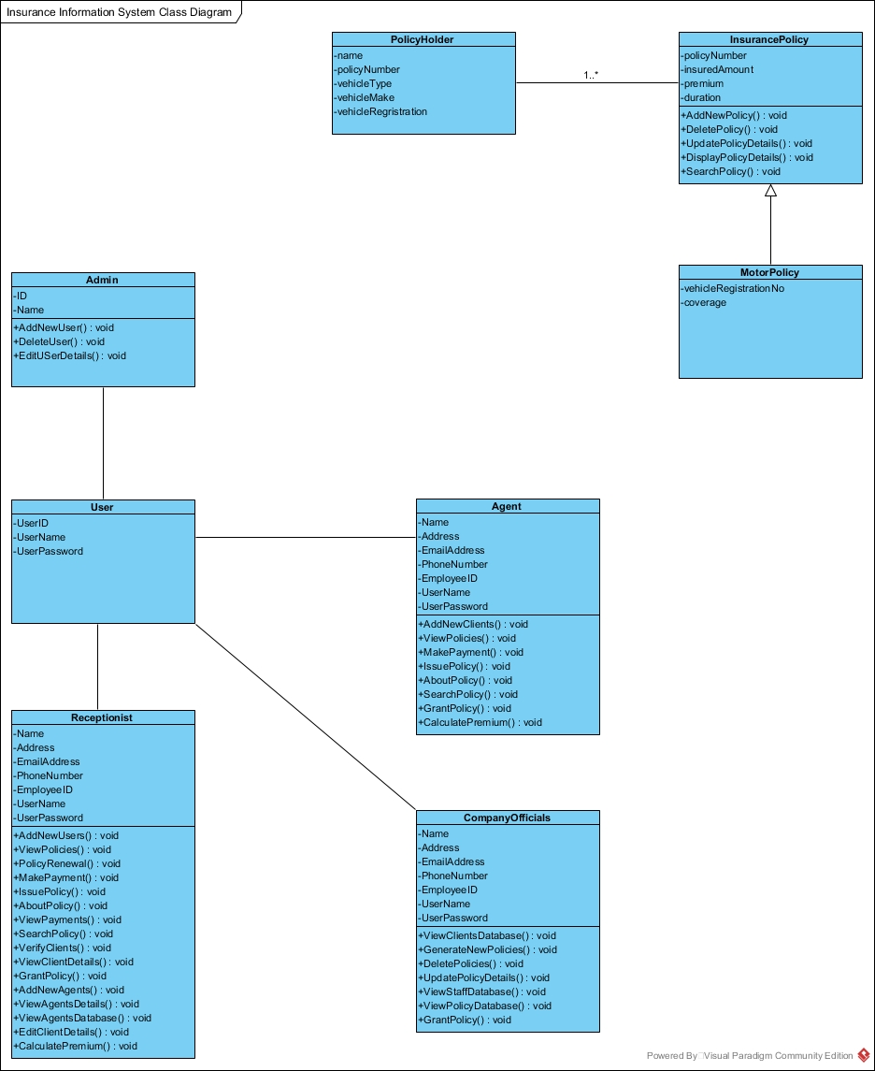

* + 1. **Activity Diagrams**

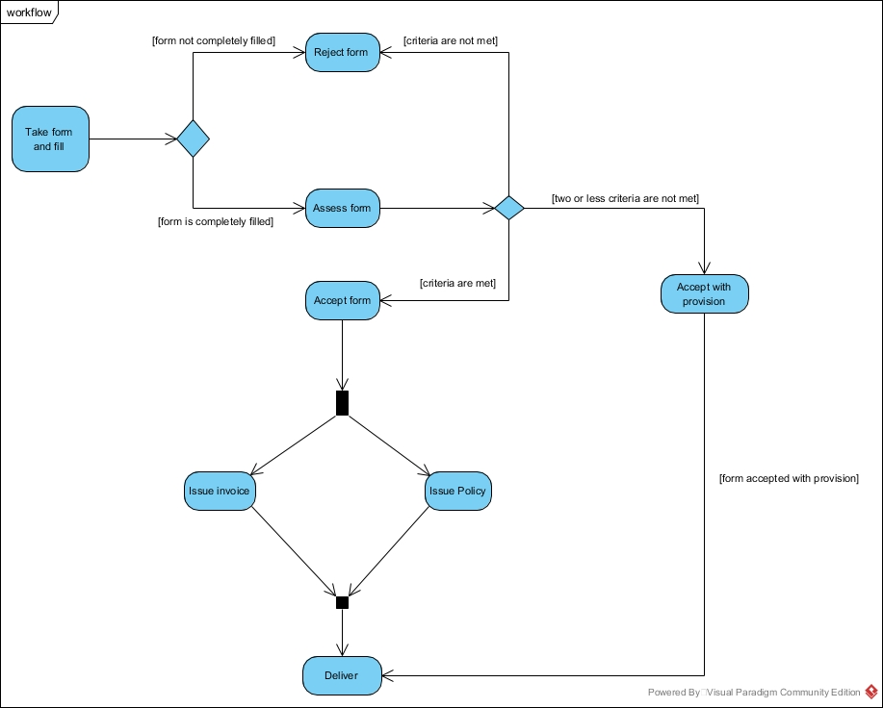

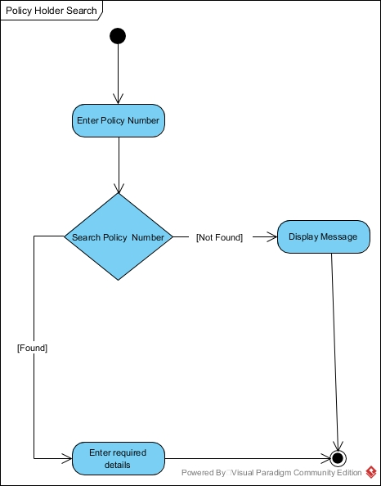

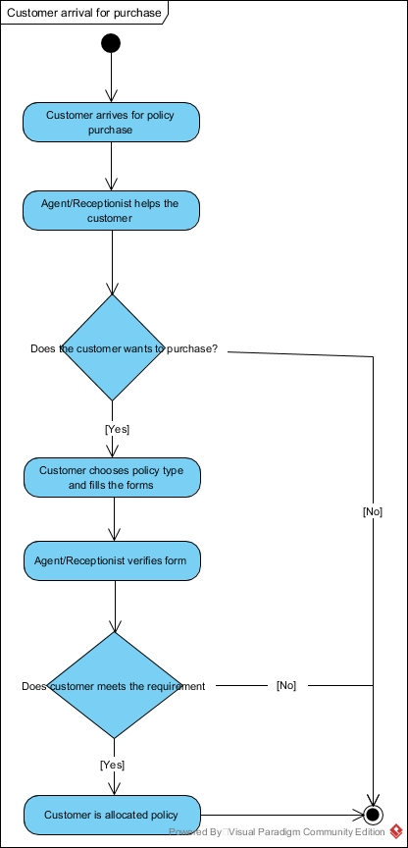

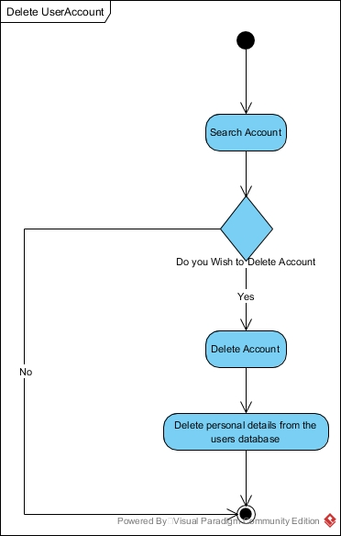

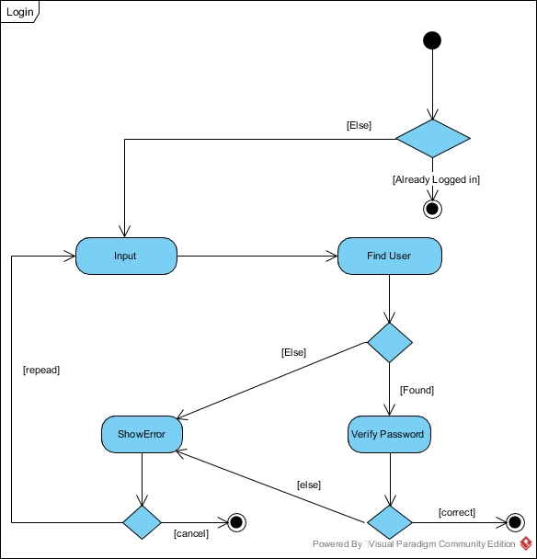

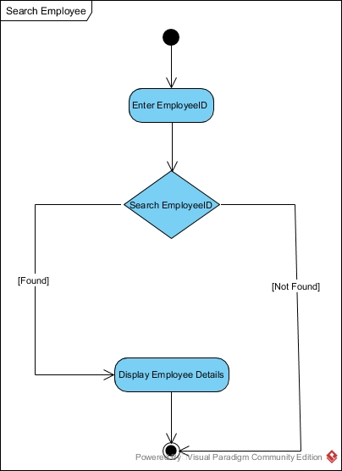

* + 1. **Use Case Diagrams**

